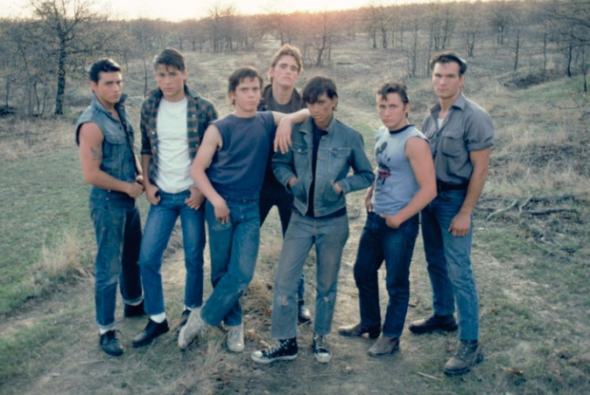
“The Outsiders” Characterization Poster

Assignment: create a poster all about a character from the novel

Poster Guidelines:
- Use half a poster board
- All work on the poster must be original
- Poster must be creative and colorful
- Write neatly, if all done by hand, use pencil then go over it with a pen or marker

Poster Must Include:
- Drawing of the character (try to be as accurate as possible) Must be drawn with a pencil, shade in with pencil or color
- Full Name and Nickname
- Include 5 character traits
- Include a quote, either said about the character, or said by the character, quote must be significant (include page #)
- Include the physical description of the character (found in Chapter 1) (bullet points ok!)
- Describe the character’s personality (How does he/she act with others? How is he/she described?)
- Give at least 4 interesting facts about the character.

*Extra Credit Opportunity +20 points!!*
- Using the information from your Character Poster, create a poem about your character
- Using the information from your Character Poster, create a Mind Map on your character
- Extra credit is optional and you may only do 1 extra credit assignment, not both

Poster is worth 50 points
Due on Monday, October 13

“The Outsiders” Characterization Poster

Assignment: create a poster all about a character from the novel

Poster Guidelines:
- Use half a poster board
- All work on the poster must be original
- Poster must be creative and colorful
- Write neatly, if all done by hand, use pencil then go over it with a pen or marker

Poster Must Include:
- Drawing of the character (try to be as accurate as possible) Must be drawn with a pencil, shade in with pencil or color
- Full Name and Nickname
- Include 5 character traits
- Include a quote, either said about the character, or said by the character, quote must be significant (include page #)
- Include the physical description of the character (found in Chapter 1) (bullet points ok!)
- Describe the character’s personality (How does he/she act with others? How is he/she described?)
- Give at least 4 interesting facts about the character.

*Extra Credit Opportunity +20 points!!*
- Using the information from your Character Poster, create a poem about your character
- Using the information from your Character Poster, create a Mind Map on your character
- Extra credit is optional and you may only do 1 extra credit assignment, not both
Poster is worth 50 points
Due on Monday, October 13

